**MC Control board program update steps**

**一、安装MDK 5 Installing software MDK5**

1. 双击MDK529.exe Double-click MDK529.exe

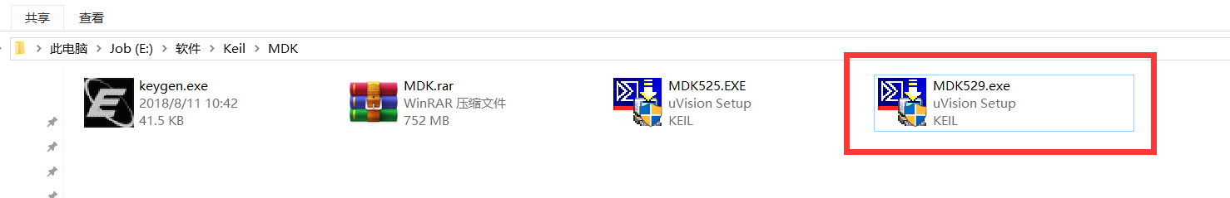

1. 一直Next安装，直到软件安装完成 Continue Next installation until the software installation is complete

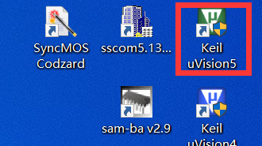

1. 安装STM32 Pack包：打开Keil 5 按以下步骤打开安装窗口 1->2（File)弹出下拉菜单选择Import... -> 选择“Keil.STM32F0xx_DFP.1.5.0.pack”进行安装

 Install STM32 Pack: open Keil 5. Follow the following steps to open the installation window 1->2 (File). -> select "Keil. Stm32f0xx_dfp.1.5.0.pack" to install

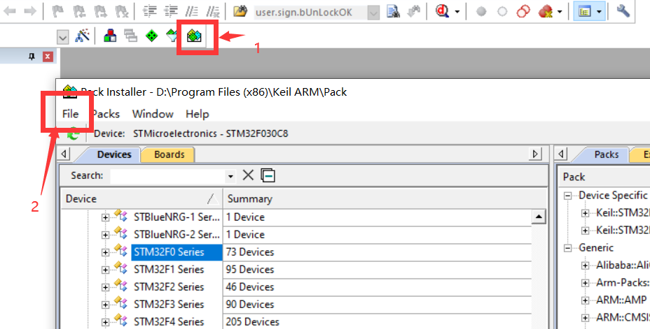

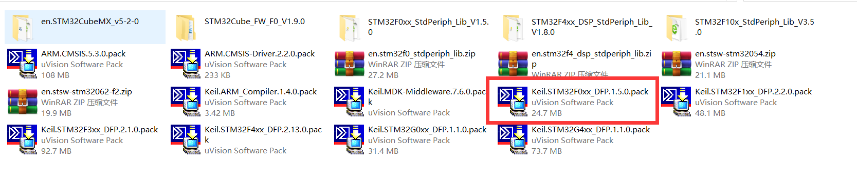

1. **J-Link驱动安装** J-link driver installation

双击Setup_JLink_V502d.exe进行J-link驱动安装 Double-click Setup JLink V502D. exe to install the J-Link driver  
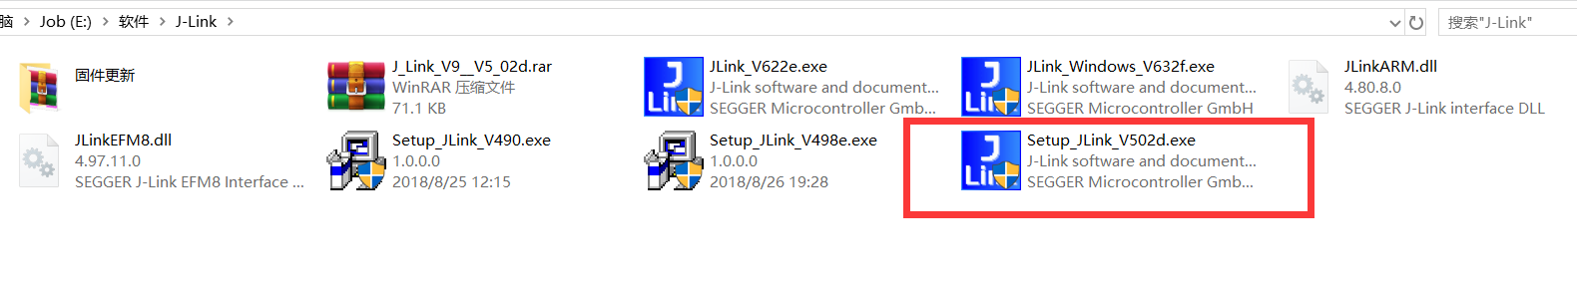

1. **硬件连接** Hardware connection
2. J-LINK SWD口连接，J-LINK是标准的ARM 20Pin JTAG端口，使用SWD口需要进行更改，JTAG接口定义如下

J-link SWD port connection. J-link is the standard ARM 20Pin JTAG port, which needs to be changed when using SWD port

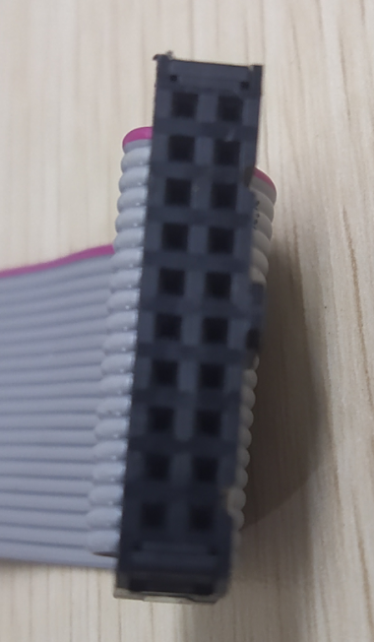

Pin10 SWCLK

Pin8 SWDIO

Pin9 GND

Pin2 VCC_OUT

Pin1 VCC

1. 将JTAG 转换为4PIN SWD，顺序为VCC -> SWDIO -> SWCLK -> GND

PS：JTAG的PIN1 和 PIN2短接，这样J-LINK可以给目标板供电同时也给SW输出IO供电。

Convert JTAG into 4PIN SWD in the order of vcc-> swdio-> swclk-> GND  
PS: JTAG PIN1 and PIN2 short, so that J-Link can supply power to target board and SW output IO.

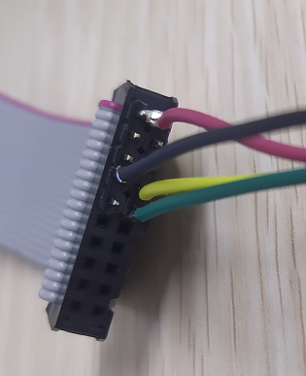

1. 将J-Link 和目标板连接，4PIN SWD接入MC 控制板的SI01接口（注意，顺序为VCC/DIO/CLK/GND 要一一对应）。正确连接后MC板的MCU接入JLINK的3.3V电压LED2指示灯亮。

J-link is connected to the target board, and 4PIN SWD is connected to the SI01 interface of MC control board (note that VCC/DIO/CLK/GND should correspond to each other in order). After proper connection, the MCU of MC board is connected to LED2 indicator of JLINK's 3.3V voltage.

PS：目标板切记不要接入AC220V，必须断开AC220V才允许接入SWD。因为SWD口是非隔离电路。Remember not to connect AC220V to the target board, AC220V must be disconnected before SWD can be connected. Because SWD port is not isolated circuit.

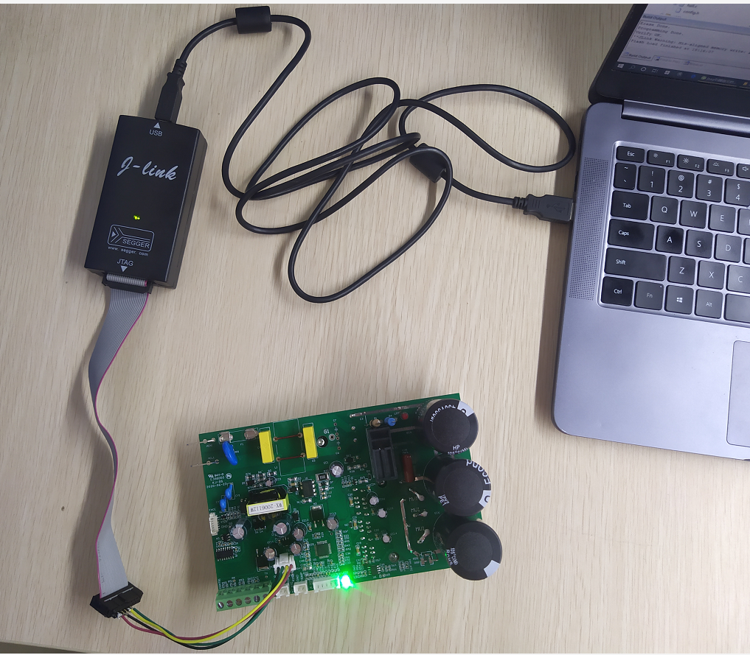

4、打开projet/ebldc_m0.uvprojx Open projet/ebldc_m0.uvprojx

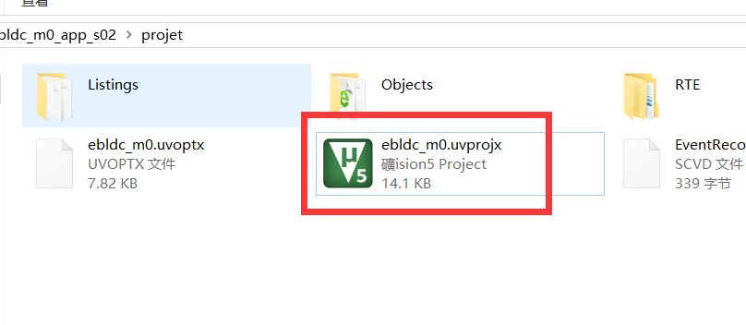

点击load按钮，程序下载，Click the load button to download the program,

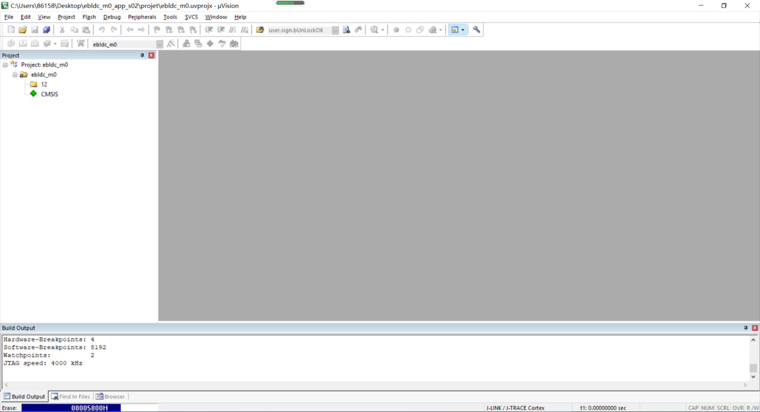

下载完成 download completes

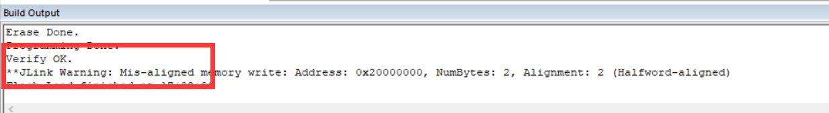

1. 程序下载完成后将SWD口移除，一定要移除。移除之后才能将MC板子接入AC220V电源中。 Remove SWD port after downloading the program. Be sure to remove it. Only after removal can MC board be connected to AC220V power supply.
2. 程序更新完成。Program update completed.